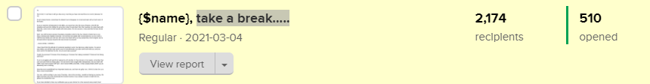
510 people opened this email: https://preview.mailerlite.com/l0m4b8

----------------------------------------------------

4th Week - February, 2021

Thurs (25th) - An email to apologize for going on a break and a break down of what’s to come.

Subject Text: take a break…..

Hi {$name},
First of all, I’m not here to tell you how sorry I am because I’m not. But if we're being honest, sometimes the Master has to disappear to come back later with a fresh vision of the future.
If you’ve read the old testament in the Bible, you would not miss the story of Moses, who left the Israelites and went into hiding for sometime; when he got down from the mountain, he came back with fresh fire, some more oil and a tablet with instructions on the right way to do life.
On account, it was said that his face shone brightly!
Well, I am still the dark caramel chocolatey storyteller. I do not have any tablet with commandments, nor do I have a staff that can divide your red sea. All I have come back with is a new perspective, fresh insights, and a renewed will to help you become the best version of yourself!
{$name}, I took a break. I needed it. And I’m back with systems in place to help me do what I have promised you.
I have found that this attitude of constantly needing to work, has become a daily routine. You eat at your desks, you still do more work in your 15-minute break, you take work home with you, and you even work in the bathroom (LOL). Do you ever take a pause?
If you’re struggling with guilt from taking time off, whether it’s five minutes or two weeks, remember that you can’t pour from an empty glass. You can be the most sought after entrepreneur, but your work will suffer if you don’t practice self-care. I don’t mean netflix and chills, I mean actual periods where you do absolutely next to nothing.
Now that we’ve established how important breaks are, and how not guilty I am, I think it is time for us to have a real conversation.
You see, I will be writing to you every Thursday - sometime late in the morning. I would be sharing my journey, the highs and lows and more importantly the lessons learned. If you would not want to read from me, please do unsubscribe now.
If you have decided to have my notification pop up your device for a few seconds every week, then I must warn you to fasten your seat belts - this is going to be one unorthodox ride!
{$name}, Captain Lamide, here. And I'm glad to be the pilot of this episode of your life.
Shall we?

Lamide Johnson
{Insert Signature} - optional

